
Yenepoya Institue of Arts Science Commerce and Management

Low Level Design (LLD)
Personalized Recommendation Engine For Healthcare

Student Name: Najiya Sulthana
23BSAMD023
LH08

BSc. Artificial Intelligence,
Machine learning and Data Science(IBM,TCS)

Industry Mentor: Mr. Sumit Kumar Shukla
Guided by: Ankitha Ma’am
Table of Contents
- Introduction
- Detailed Module Design
- Algorithm Design
- Data Structures
- Function-Level Design
- Error Handling
- Interface Design
- Performance Considerations
- References

1. Introduction
1.1 Scope of Document
This document provides a detailed internal design of the Healthcare Recommendation System including module-level implementation, algorithms, and data handling mechanisms.
1.2 Intended Audience
- Developers
- Evaluators
- Project reviewers
1.3 System Overview
The system is a content-based healthcare recommendation engine that suggests similar healthcare items such as diseases based on user input.
It uses Natural Language Processing techniques like TF-IDF and Cosine Similarity to analyze textual data and generate relevant recommendations.

2. Detailed Module Design
2.1 Modules
1. Input Module
• Accepts user input
• Handles text input through search bar
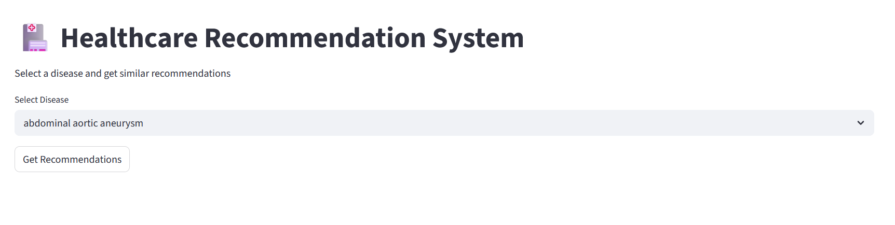
2. Data Processing Module
• Reads dataset (CSV file)
• Cleans data (removes duplicates, converts text to lowercase)
• Combines tags and prepares data for processing
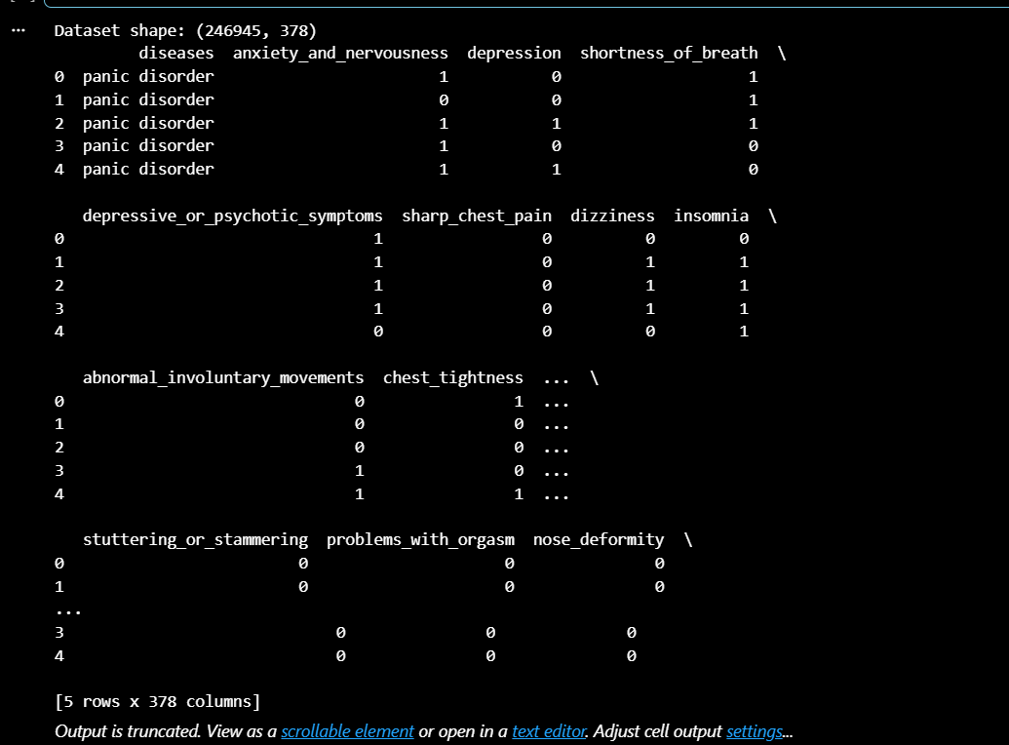

3. Recommendation Engine
• Identifies similar healthcare items
• Uses TF-IDF for feature extraction
• Uses cosine similarity for matching
• Filters top relevant results
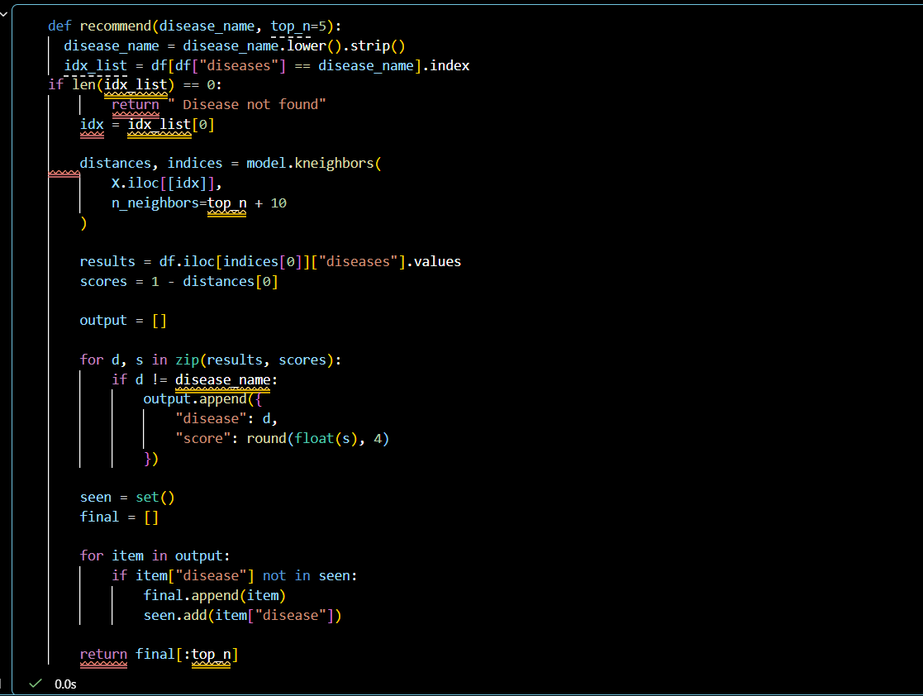

4. Similarity Computation Module
• Converts text into numerical vectors
• Calculates similarity between items
• Generates similarity matrix

5. Output Module
• Displays:
o Recommended healthcare items
o Graphs (line chart, histogram)
o Final suggestions
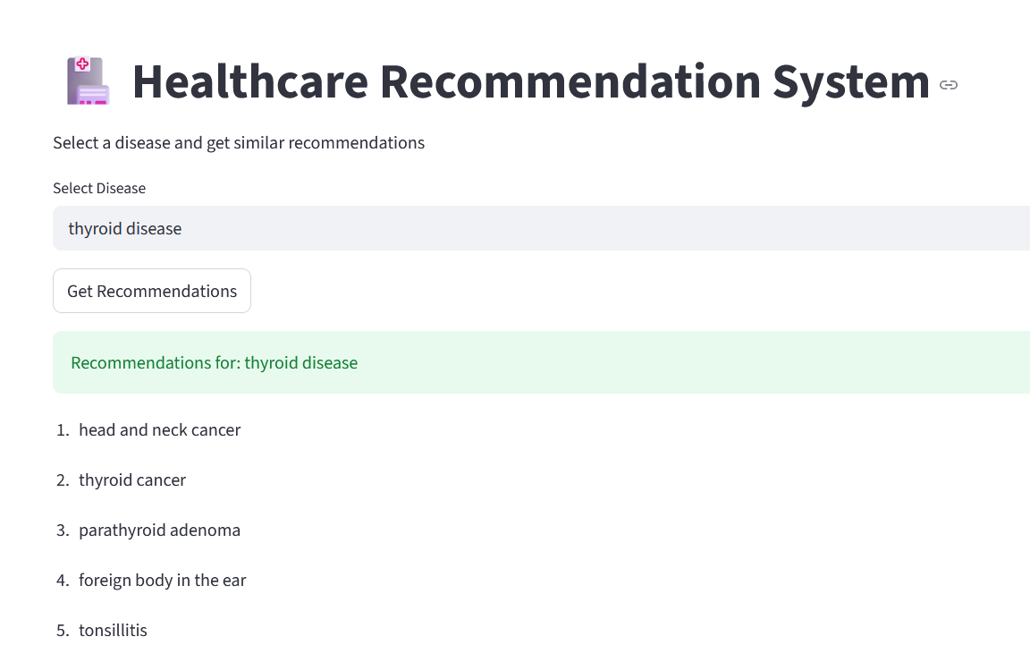

3. Algorithm Design
3.1 Recommendation Algorithm
Steps:
- Take user input (healthcare item)
- Convert input to lowercase
- Check if item exists in dataset
- Convert dataset text into vectors using TF-IDF
- Compute cosine similarity
- Retrieve similarity scores for selected item
- Sort items based on similarity
- Remove duplicate recommendations
- Return top results

3.2 Text Similarity Algorithm
- Convert text data into TF-IDF vectors
- Represent each item as a vector
- Compute cosine similarity between vectors
- Return similarity score between items

4. Data Structures
Data | Structure
Healthcare dataset | Pandas Data Frame
Tags & text data | String
Recommendations | List
Duplicate filtering Set

5. Function-Level Design
5.1 load_data()
• Input: dataset file
• Output: cleaned DataFrame
• Removes duplicates and formats data

5.2 build_model()
• Input: dataset
• Output: similarity matrix
• Applies TF-IDF and cosine similarity

5.3 recommend(item)
• Input: healthcare item
• Output: list of recommended items
• Returns top similar results

5.4 main_app()
• Controls application flow
• Takes input and displays output

6. Error Handling
• Missing dataset → handled with file error
• Invalid input → shows “Item not found” message
• Duplicate entries → removed during preprocessing
• Empty results → displays fallback message

7. Interface Design
7.1 User Interface
• Built using Streamlit
• Input via search bar
• Button to generate recommendations

7.2 Output Interface
Displays:
• Recommended healthcare items
• Graphs (line chart, histogram)
• Clean card-style results

8. Performance Considerations
• TF-IDF efficient for small datasets
• Cosine similarity fast for comparison
• Duplicate removal improves accuracy
• Limited recommendations (top 5) for speed
• Lightweight UI using Streamlit

9. References
• Scikit-learn Documentation (TF-IDF, Cosine Similarity)
• Pandas Documentation
• Streamlit Documentation
• Research papers on Recommendation Systems
• Online tutorials on Content-Based Filtering

